Struktur Database Classicmodels

Table Customers

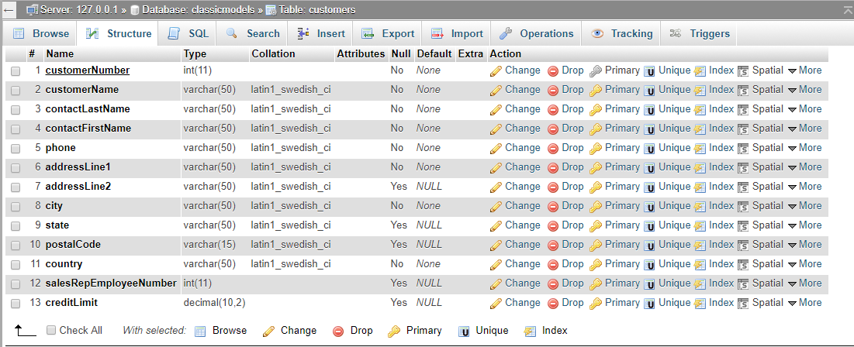

Table Employees

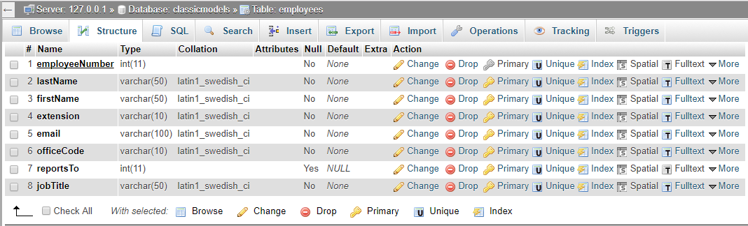

Table Offices

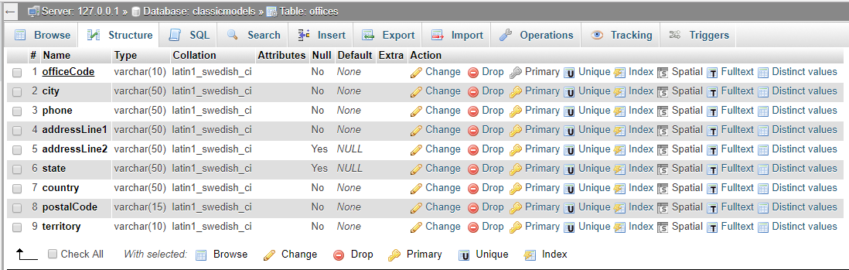

Table Orderdetails

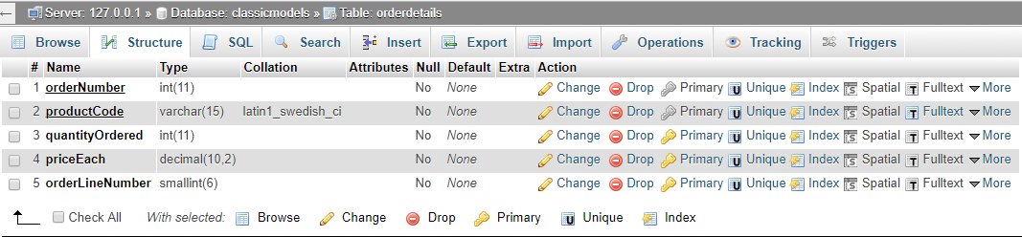

Table Orders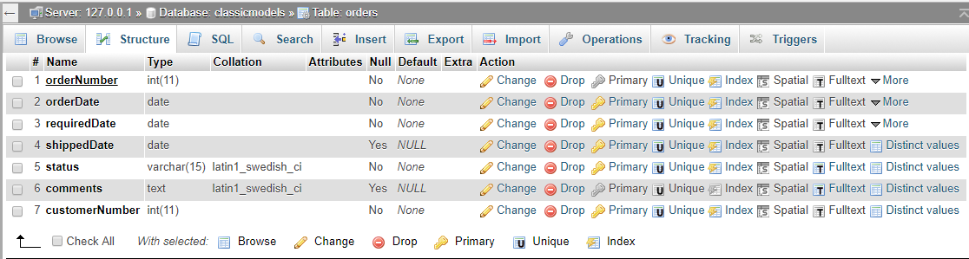

Table Payments

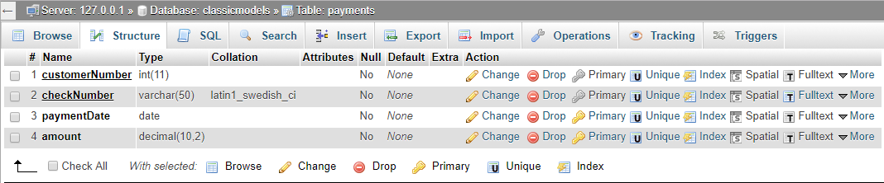

Table Productlines

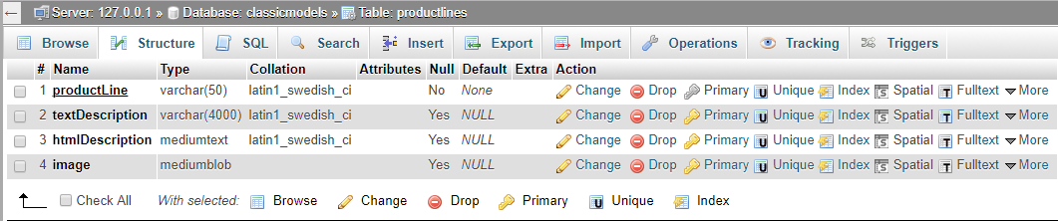

Table Products

